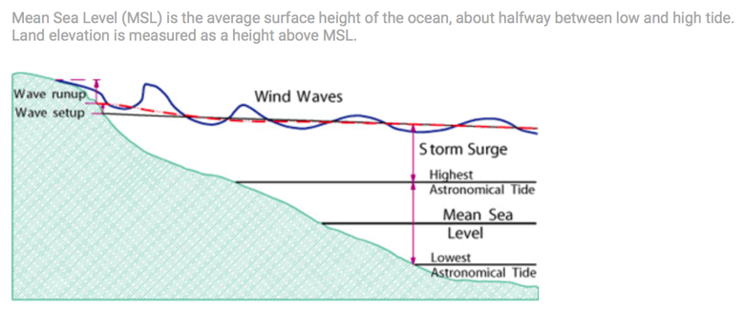

Graphic and Explanation developed by Dr. Keren Bolter

