Pictures of Climate Change Impacts in Palm Beach King Tides are the highest of the high tides that occur twice a year. In Florida they occur in fall and in spring. King Tide pictures taken in various municipalities in Florida coastal communities appear below, and can be used on tabling posters. Try to find local photographs so people are familiar with the inundated areas.

Note that these are photographs showing tidal flooding. There is no storm precipitation causing the flooding shown.

Boca Raton Lake Wyman Park Soccer Fields and Trails: September 2015 King Tide
Photograph by Natalie Schneider PBC

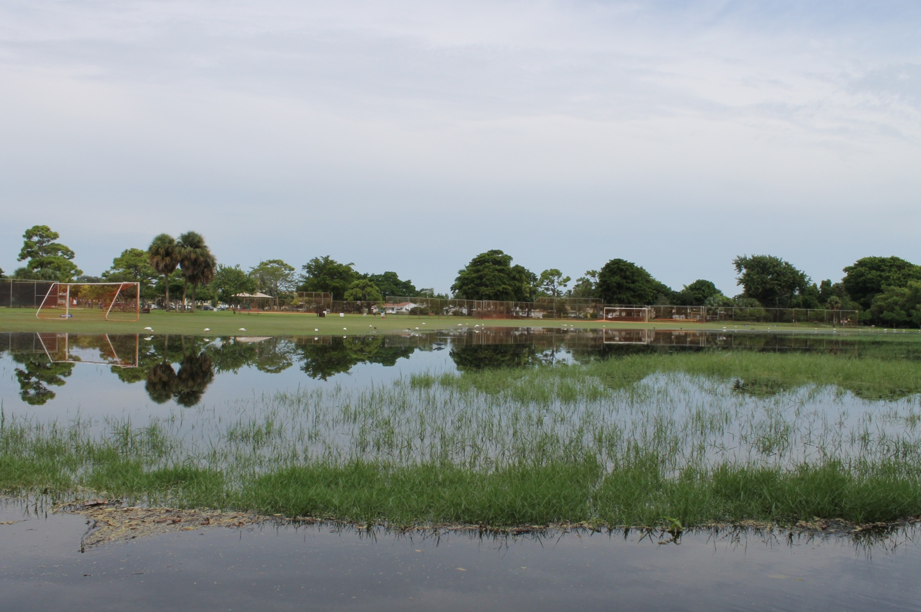

Boca Raton Por la Mer Intersection: September 2015 King Tide
Photograph by Natalie Schneider PBC

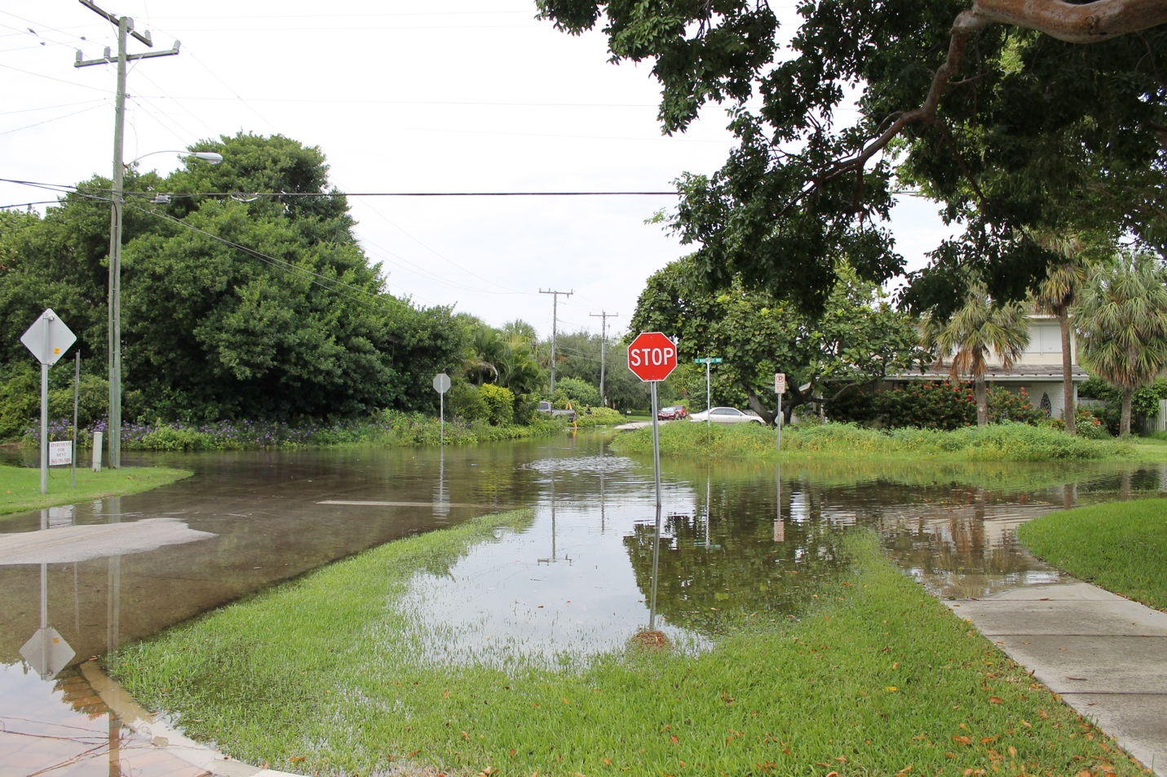

Boca Raton Por La Mer Residences: September 2015 King Tide
Photograph by Natalie Schneider PBC

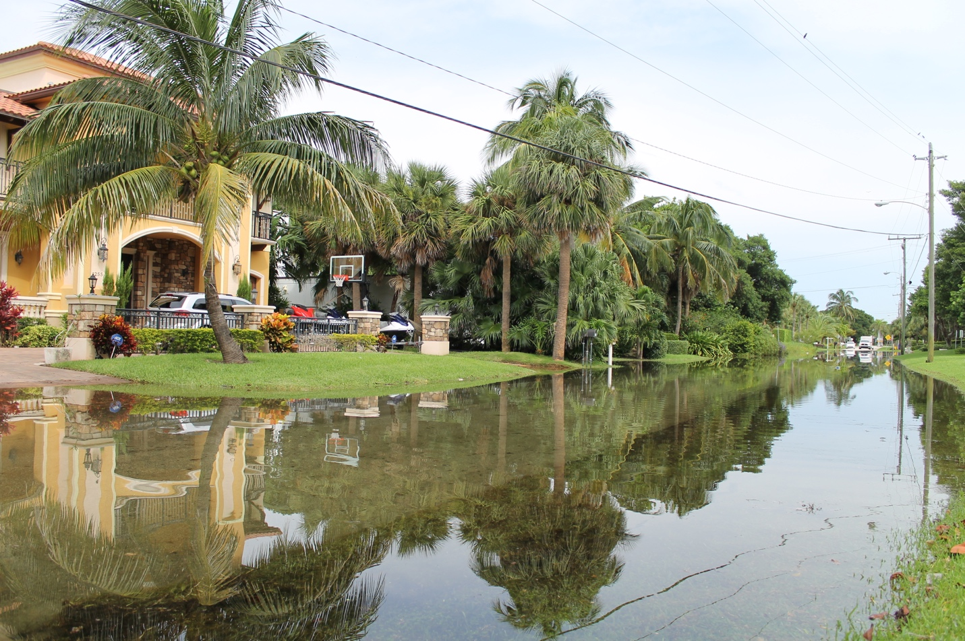

Boca Raton Silver Palm Park Boat Ramp: September 2015 King Tide
Photograph by Natalie Schneider PBC

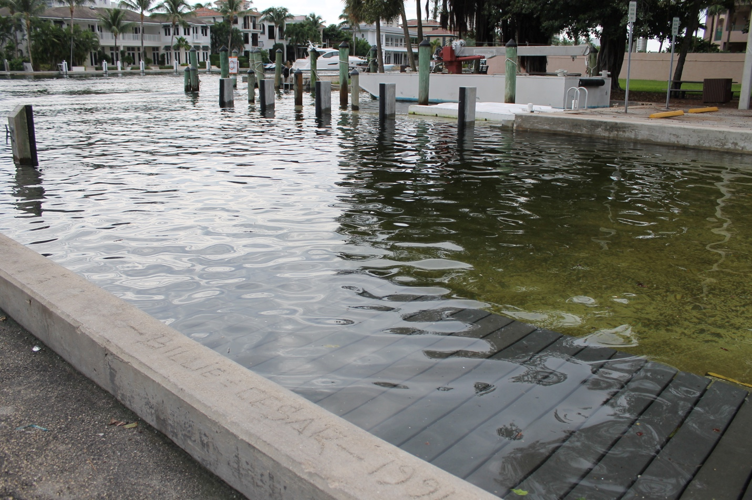

Boca Raton Silver Palm Park Driveway: September 2015 King Tide
Photograph by Natalie Schneider PBC

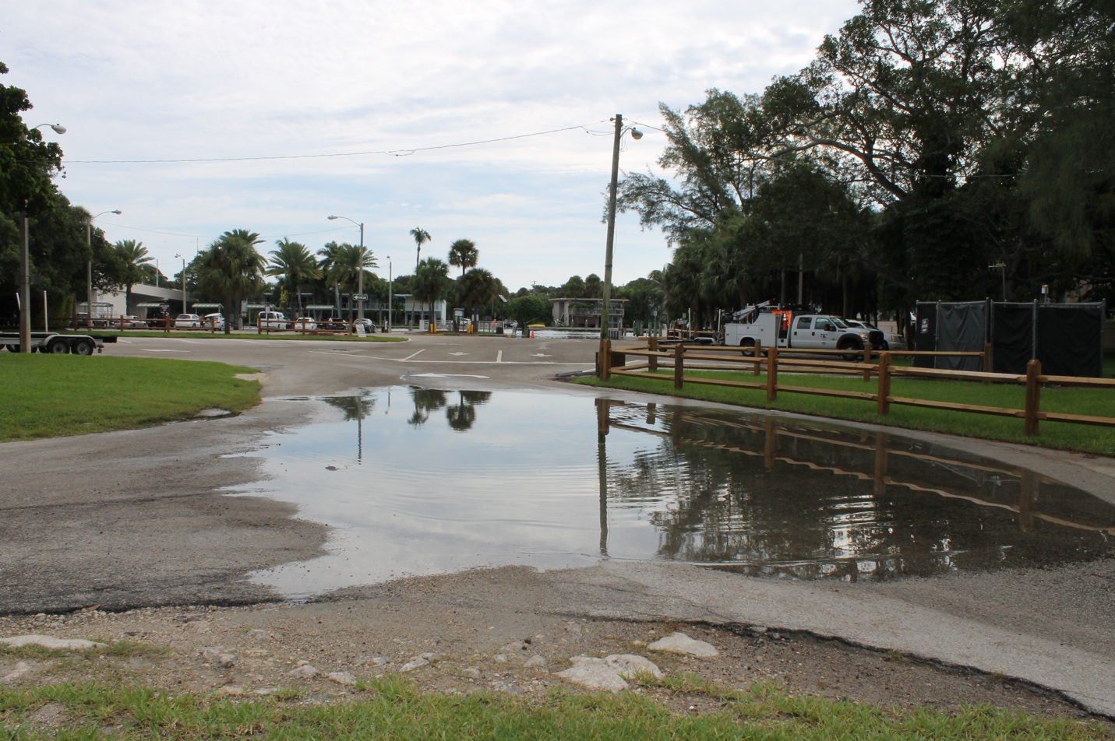

Boynton Beach Ocean Inlet Park: September 2015 King Tide
Photograph by Natalie Schneider PBC

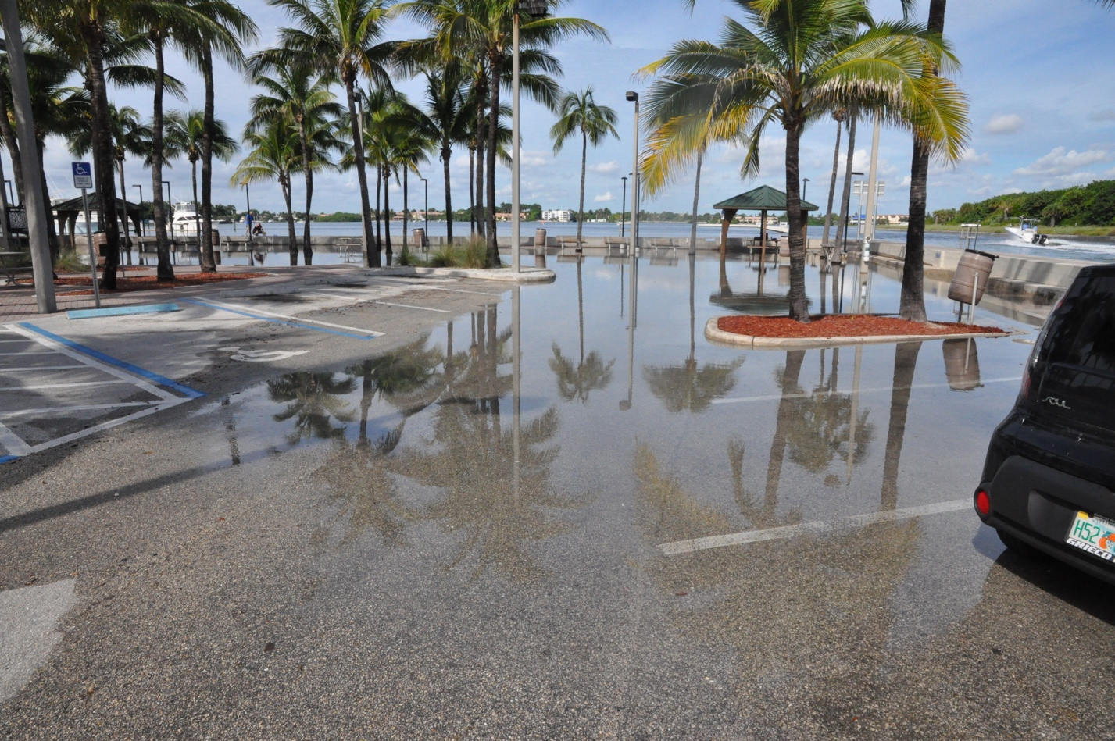

Boynton Beach Banana Boat Restaurant: September 2015 King Tide
Photograph by Natalie Schneider PBC

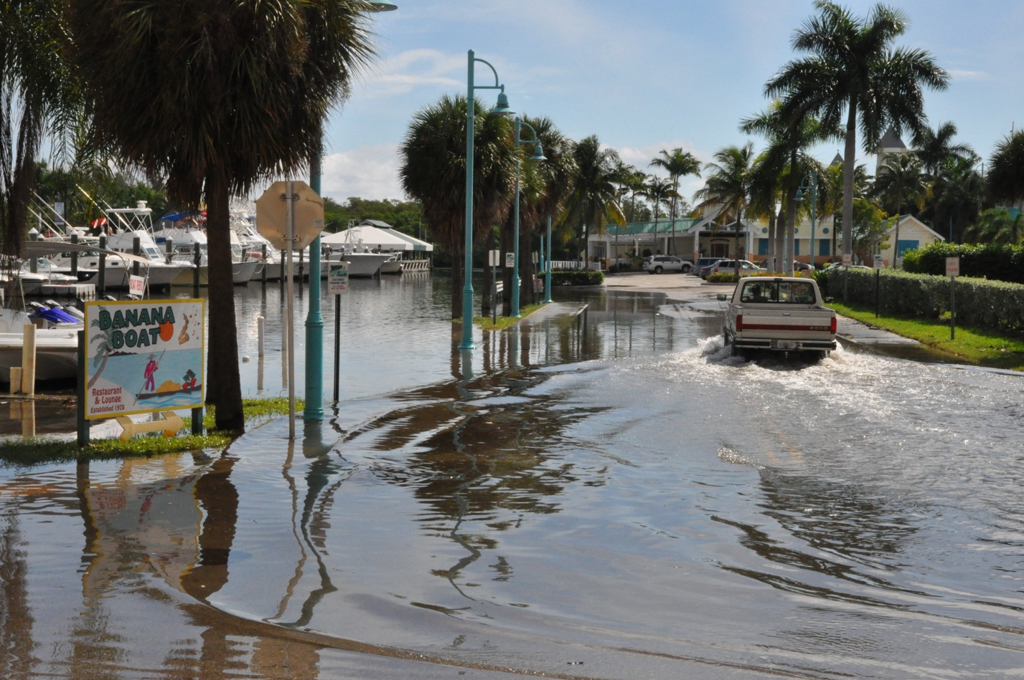

Boynton Beach: Boynton Harbor Marina entrance September 2015 King Tide
Photograph by Natalie Schneider PBC

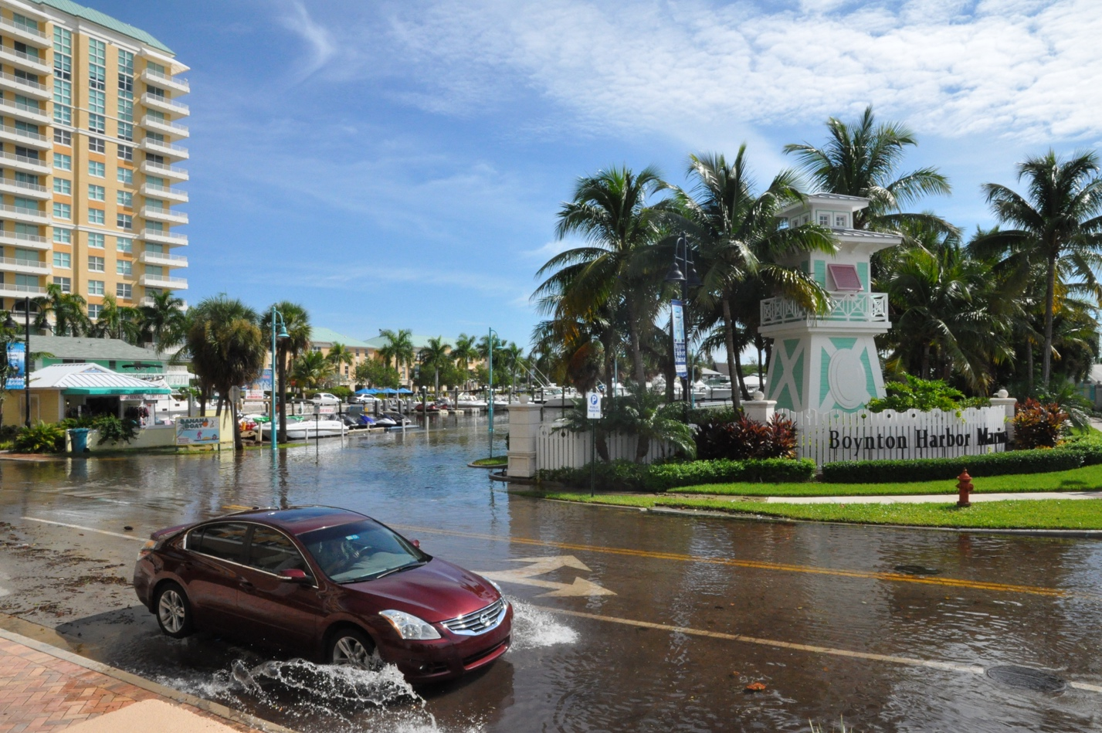

Delray Beach: Brooks Lane Residence: September 2015 King Tide
Photograph by Natalie Schneider PBC

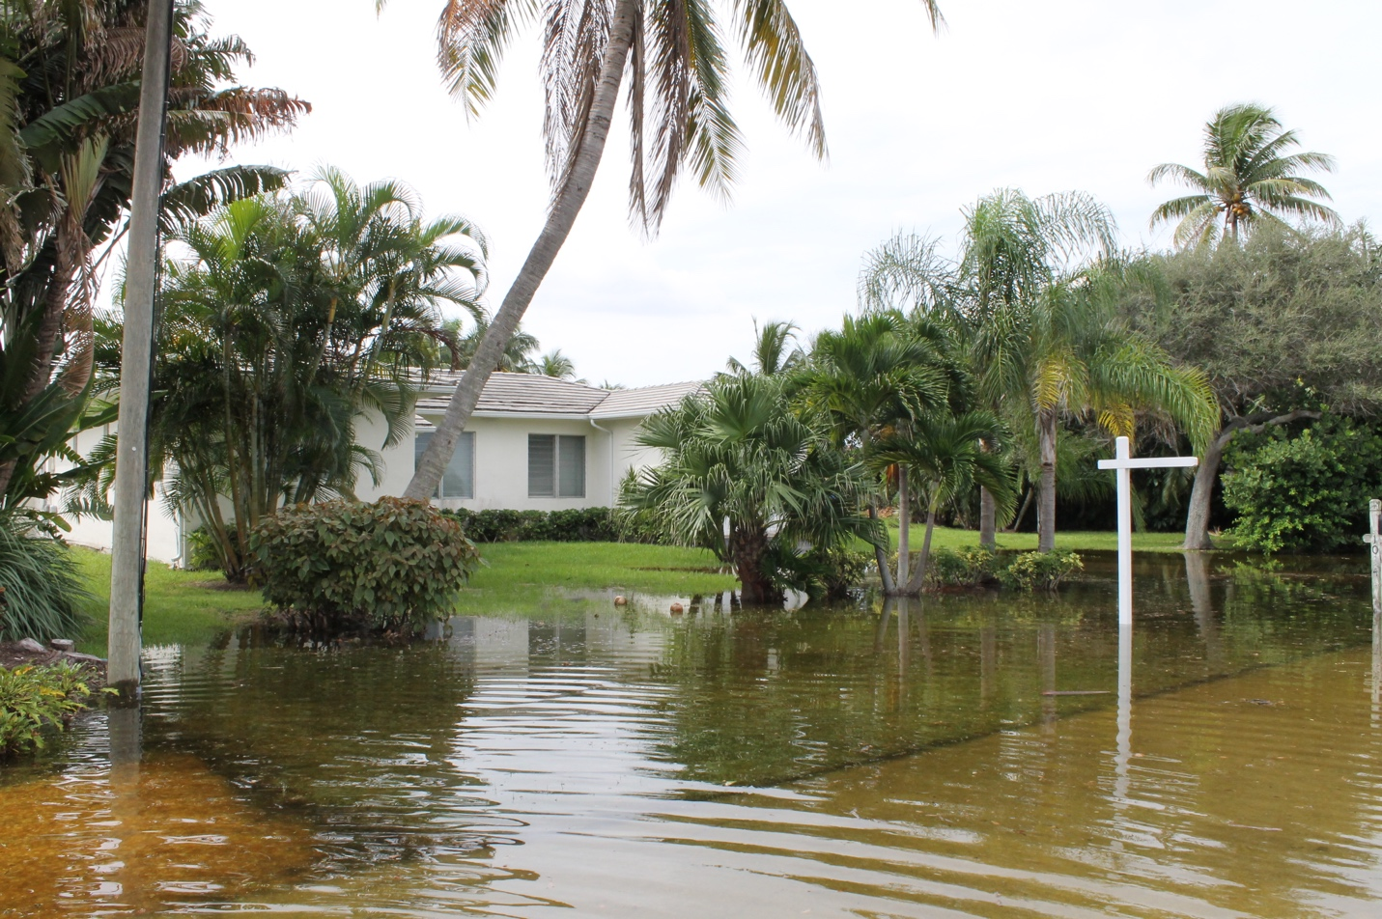

Delray Beach Brooks Lane September 2015 King Tide
Photograph by Natalie Schneider PBC

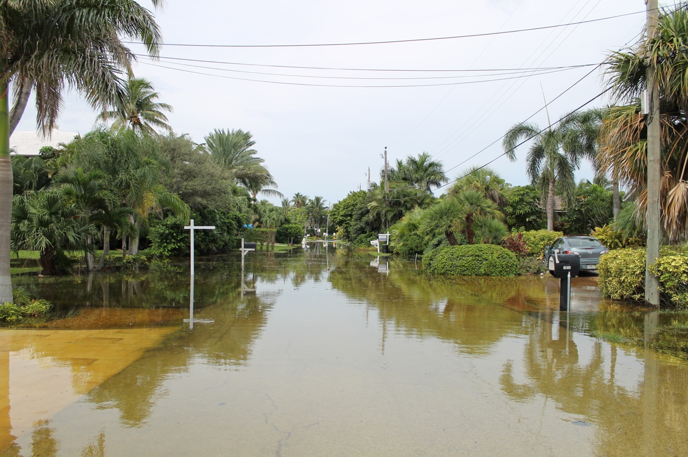

Delray Beach: Delray Marina September 2015 King Tide
Photographed by Natalie Schneider PBC

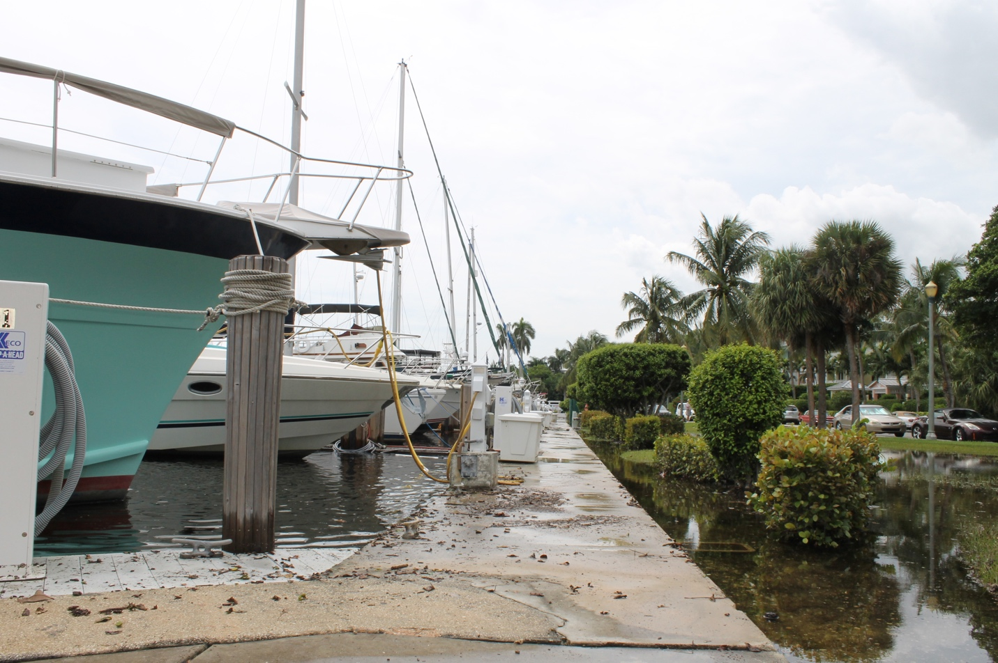

Delray Beach North Marine Way: September 2015 King Tide
Photographs by Natalie Schneider PBC

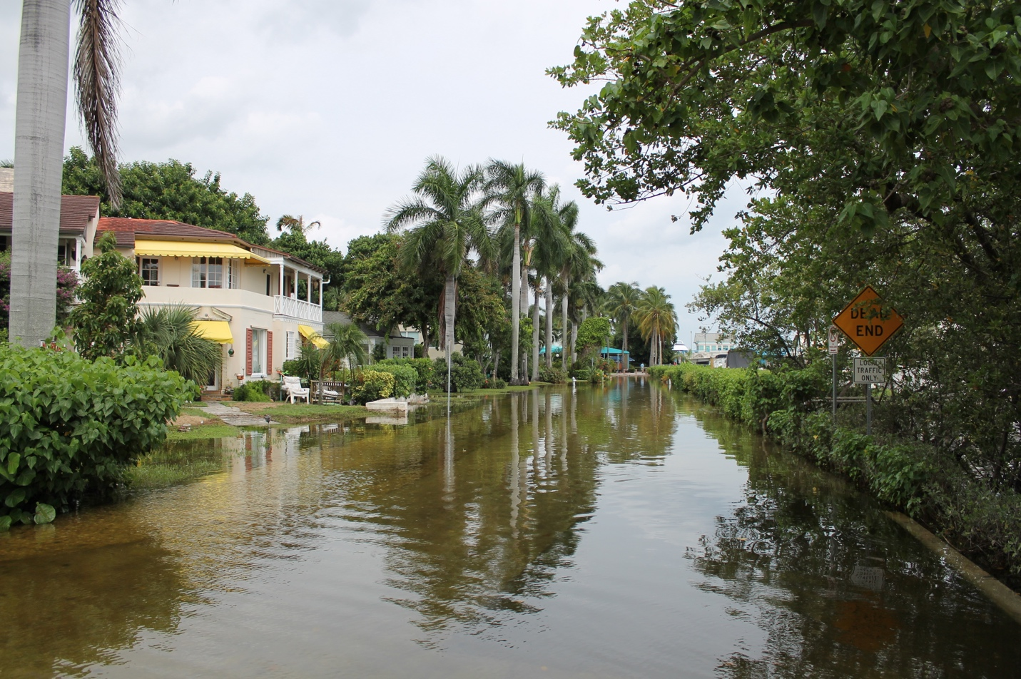

Delray Beach South Marine Way: September 2015 King Tide
Photographs by Natalie Schneider PBC

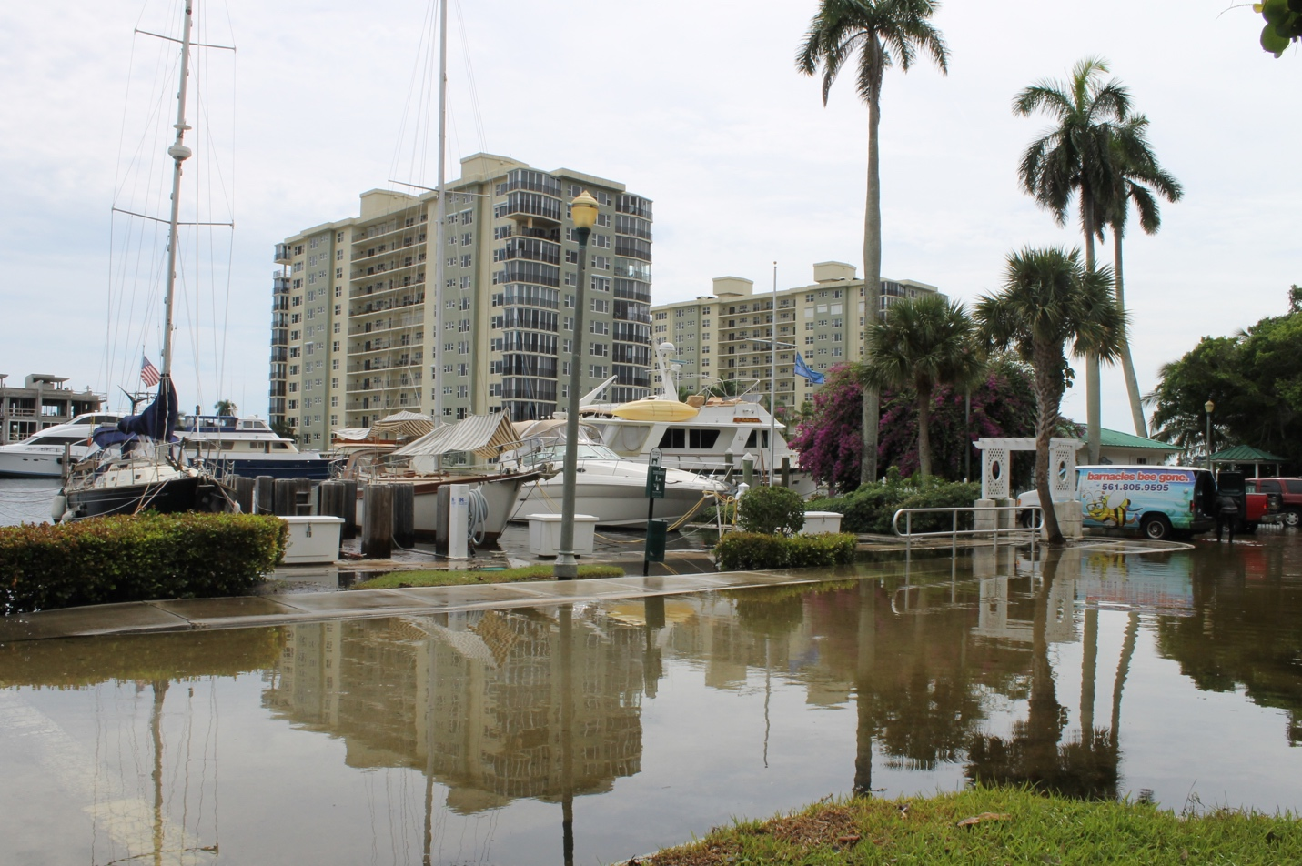

Seasage Dr. and Casuarina Rd.: September 2015 King Tide
Photographs by Natalie Schneider PBC

