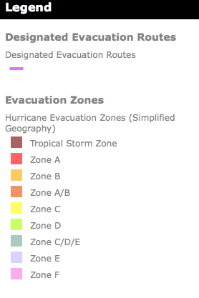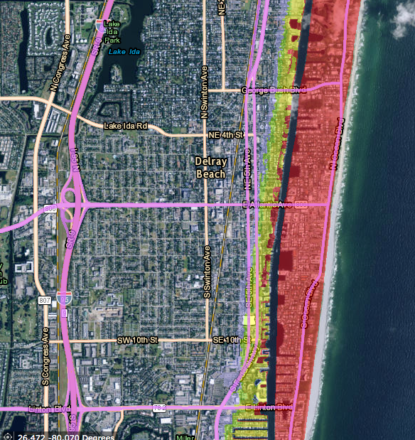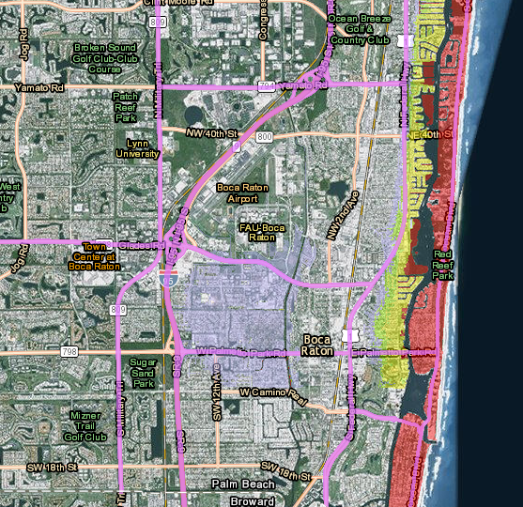 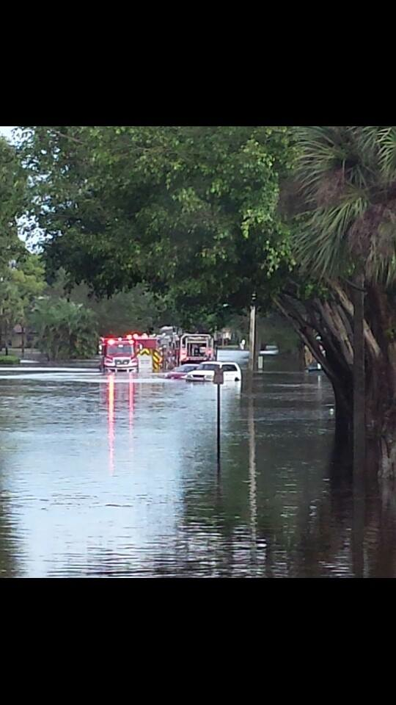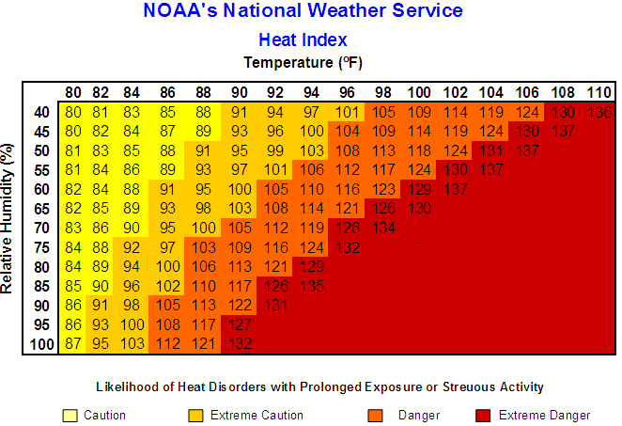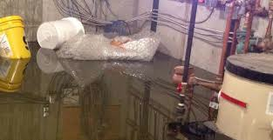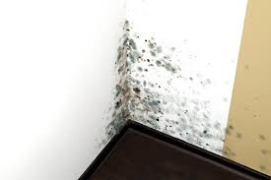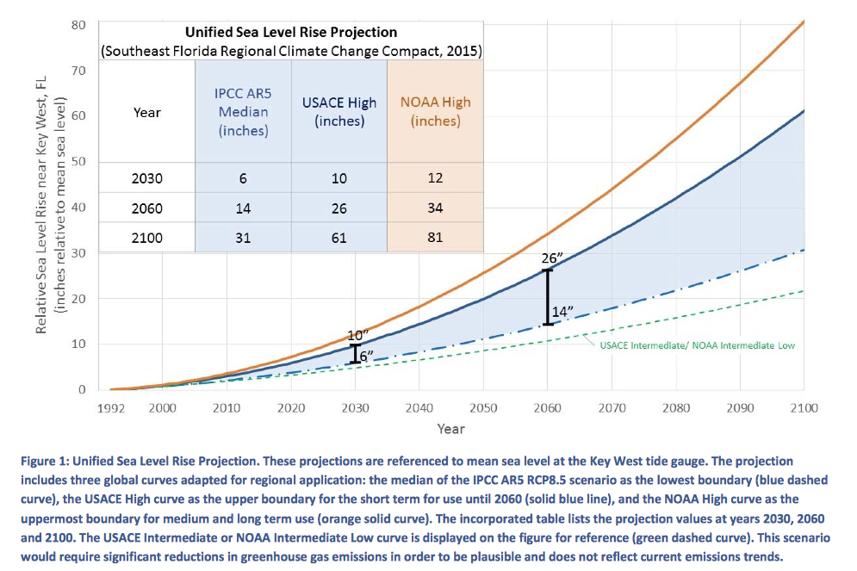

Developed by Dr. Ana Puszkin-Chevlin Green Sanctuary Committee of UUFBR EPA Grant #EQ-00D35415-0

Sign Up for telephone alerts https://public.**codered**web.com

Pearl City Vicinity

West Atlantic Neighborhood

## State of Florida Contacts

## Palm Beach County Contacts

## Boca Raton & Delray Beach Contacts

Evacuation Zones and Routes

**Radio Stations with Emergency Information**

Delray Beach Emergency Radio 1620 AM

**Homeland Security Emergency Radio Stations**

City of Boca Raton AM 1650 kHz

City of Boynton Beach – AM 1670 kHz

City of Delray Beach – AM 1700 kHZ

NOAA Weather Radio – KHB34 162.550MHz

Coverage Miami/Dade, Broward, South Palm Beach County

NOAA Weather Radio KEC50 162.475 MHz

Coverage North Broward, Palm Beach and Martin County

Florida Emergency Information Line (800) 342 3557

Florida Department of Emergency Management

(850) 413-9969 Hearing Impaired (800) 226-4329

Florida Dept. of Public Health –water testing (850) 245-4240

***Report ALGAE Blooms to*** Dept. Environmental Protection, Bureau of Labs (850) 245-8159 or Dept. of Health, Aquatic Toxins Program (850) 245-4250

(850) 245-4250

PBC Emergency Management* (561) 712-6400

Get PBC DART free app with information to prepare for storm emergencies.

* *Pre-register for emergency needs shelter at 561 712-6400*
* *Pre-register for Emergency Disabled Transportation Assistance at and Palm Tran Connection* (561) 649-9848

PBC Emergency Mgmt. Flood Mitigation Assistance

(561) 712-6325

PBC Water Utilities Emergency (561) 740-4600 Option 1

Report Disease to PBC Dept. of Health (561) 671-4184

***Report Mosquito Infestations to***

Mosquito Control Division (561) 967-6480

Air Spray HOTLINE (561) 641-8775

FPL Florida Power & Light (800) 226-3545 or (561) 994-8227

Boca Raton Fire Rescue 561 982-4000

Boca Raton Police Department 561 338-1234

Delray Police Department 561 243-7800

Delray Beach Fire Rescue 561 243-7400

Delray Beach Hurricane Information Hotline 561 243-7840

Boca Raton Citizen Emergency Info. Ctr. 561 982-4900

Dial 211 – For referrals to all types of Human Services

Rising Together:

Temperature, Water, Health and Strength

2016

Continued on page 2

Be Safe During Storms and Floods

Assume Standing Floodwater is Contaminated

* Floodwaters are often contaminated with fuel, chemicals, sewage and bacteria.
* Avoid ALL contact with floodwaters, and avoid inhaling evaporating fumes.
* Clean all hard surfaces with a solution of 1.5 cup bleach to 1 gallon of water.
* Wear rubber boots and gloves and a mask during cleanup.
* Do not expose open wounds to flood waters.
* Throw out ALL food that had contact with floodwater. Disinfect canned goods before opening.
* Don’t drink, make ice, prepare food or brush teeth with tap water. Use bottled water if possible.
* Don’t wash dishes, glasses, or cutlery in tap water. Use boiled water.
* Don’t wash hands, expose open wounds or bathe babies in tap water.
* Bringing water to a roiling boil for a minimum of 1 minute, or disinfect with 8 drops of unscented bleach per
* After a boil water alert is finished, run the water from all faucets for 5 minutes and change filters of water and ice systems.

Heed the Boil Water Alert Guidelines

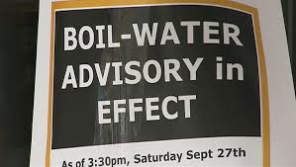

* Molds are allergens; some produce toxins or release volatile compounds from materials.
* Active mold is black, green or pink. Inactive mold is powdery and often white, but will reactivate with moisture.
* To prevent mold, dry things as quickly as possible.
* Throw out items that have been wet for more than 48 hours. Freezing deactivates mold.
* Homeowners can clean moldy areas less than 10 square feet with a solution of 1 cup bleach per 1 gallon of water. Wear gloves and a mask. Professionals should address larger mold areas and clean air-conditioning systems.

Watch for Heat Index and Air Quality Alerts

* Keep storm drains, canals and gutters clear of debris to prevent floods and water damage.
* Stay Informed. Create a plan with your family and an emergency kit prepared, before an emergency .
* Communicate with family, friends and neighbors about your emergency plan.
* If you shelter in place, stock 1 gallon of water per person, per day; a 4-5 day supply, plus food.
* **STAY OUT** of floodwaters. 6” of moving water can sweep you off your feet. Water depth is difficult to gauge and hazards could be submerged.
* Do NOT push a stalled car, 12” of moving water can float a car down stream
* Information about the heat index can be found at www.nws.noaa.gov/om/heat/heat-illness.shtml
* Get air quality reports from [www.airnow.gov](http://www.airnow.gov), or call 561 837-5092 to hear report.
* Heat Index over 103**°**, be cautious! Vulnerable populations are at risk with a the heat index of 91**°**
* Remain indoors in air-conditioned places during heat waves and poor air quality days.
* If outdoors, avoid strenuous activity, stay hydrated .
* If you shelter in place, stock 1 gallon of water, per person, per day, 3-day supply, plus food.
* Do NOT push a stalled car, 12” of moving water can float a car down stream

Minimize Mold Growth

Limit Exposure to Mosquitos and Algae

* Eliminate mosquito-breeding areas. Drain items that collect water outdoors including flowerpots, birdbaths, buckets, drums, child pools, etc.
* Minimize mosquito bites. Wear long sleeves, long pants and socks outdoors, especial around dawn and dusk..
* Use insect repellent with DEET or oil of lemon eucalyptus. Limit DEET exposure in young children by washing it off before bed.
* Report algae blooms to Florida DEP, Bureau of Labs (850) 245-8159. Algae can be toxic and must be tested.

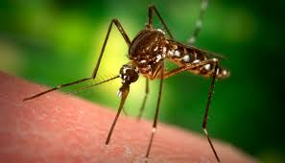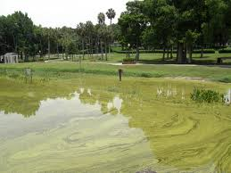

[Web address]

Lorem Ipsum Dolor

93 Perry Street  
Error! Bookmark not defined., Error! Bookmark not defined.Error! Bookmark not defined.