Sea Level Rise Risk Perception Survey
Thank you for your interest in taking this brief survey. It may take about 5 minutes to answer the questions below. Your participation in this survey is completely voluntary and your responses will remain confidential. The purpose of the survey is to measure perceived risk to sea level rise in Palm Beach County, FL. Sea level rise is an increase in sea surface height relative to land. A potential benefit that you may receive from participation is consideration of how you evaluate your risk to sea level rise. The results will give Palm Beach County educators information about demographics and locations where risk is underestimated or overestimated. If you have questions about the study, please contact: Dr. Keren Bolter at kbolter@fau.edu. By completing the survey, you give consent to participate in this study.
Section A-Background Information
- What is your zip code _________________
- What city do you live in? ______________________________
- What is the first line of your address? ______________________________________
- How would you rate your existing knowledge about sea level rise?
  - Not at all familiar
  - Somewhat familiar
  - Very familiar
  - Extremely familiar

Section B-Land Elevation, Water Levels, and Storms
Sea level rise is an increase in height of the sea’s surface relative to land.
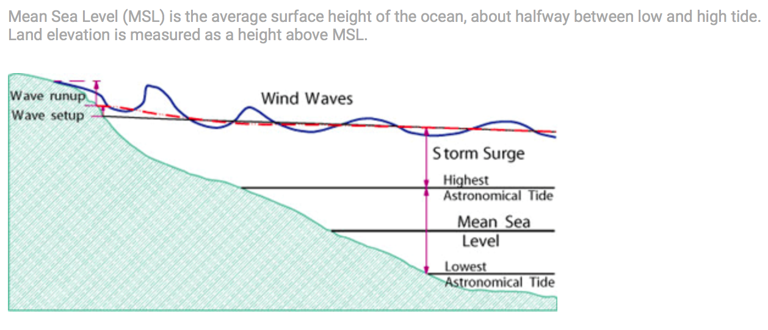

- How many feet do you estimate your home to be above mean sea level? (If you do not know, please guess a number that seems reasonable to you.)
_________________________________
- Do you think that sea level rise is occurring in Palm Beach County today?*
  - Yes
  - No

- Where you live, how many feet deep into the ground do you think that you would have to dig before you got to water? (either freshwater or saltwater)
_________________________________
Section C – Focusing on Risks Associated with Sea Level Rise and Extreme Weather

- What is your overall level of concern with the future impacts of sea level rise for Palm Beach County?

None Low Medium High Very High
1 2 3 4 5

- What is your overall level of concern with the future impacts of extreme weather for Palm Beach County?

None Low Medium High Very High
1 2 3 4 5

- Please choose your strongest concern for Palm Beach County:
    - Water Quality
    - Erosion
    - Insurance
    - Property Value
    - Extreme Weather
    - Other: _____________________

- Please explain your chosen concern (optional)

- What flood-related impacts have you experienced in your neighborhood? These may include high tide flooding, flooding with no rain, or saltwater in retention ponds (optional)

- Have you or anyone in your household experienced any of the following at your current address?

Mold Yes No
Asthma Yes No
Water Contamination Yes No

