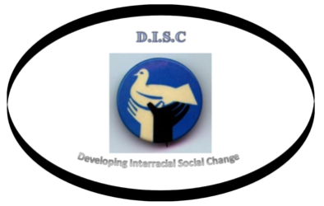

Rising Together: Temperature, Water, Health and Strength
September 15, 2016
Friendship Baptist Church
1421 NE 2nd Court, Boca Raton, FL

A Community Environmental Justice Project Hosted by DISC

- Welcome Reverend Davis
Friendship Baptist Church
- Opening Invocation Reverend Harris
Unitarian Universalist Fellowship
of Boca Raton
- Acknowledgments Dr. Weiss-Randall
- Rising Together presentation Marjorie O’Sullivan
Marie Hester
LeJeune Goddard
- Rising Together slide show Dr. Weiss-Randall
- DISC welcome Allen Willis
John E. Brown
- CERT Fire Chief Davanzo
- American Lung Association Asthma Expert Mr. Cuddihy

Refreshment Break*
- Q & A
- DISC Closing

*Special thanks to Mr. & Mrs. Robert Chastain for providing the sandwich and fruit platters

