The Pearl City/Dixie Manor Community presents
Rising Together!

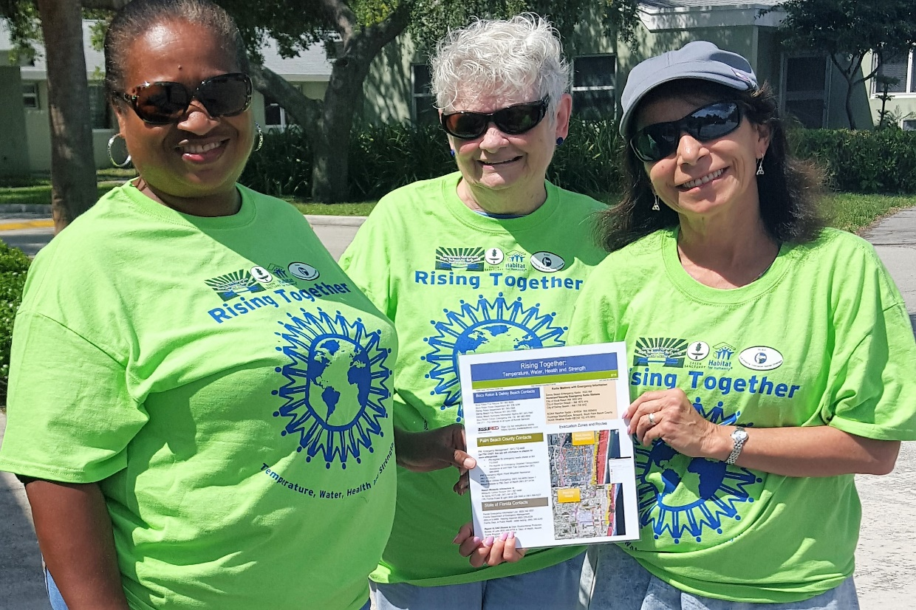

Come honor our outreach workers from DISC for their great work on environmental justice and public health!
Thursday, September 15

6:30pm Friendship Baptist Church
1421 NE 2nd Court, Boca Raton, FL

Free refreshments!

For more info, call Dr. Debra Weiss-Randall at 914-572-2126,
Marjorie O’Sullivan at 561-213-6214, or LeJeune Goddard at 813-382-5120.

Join us for a presentation on our Rising Together project, which empowers communities to stay safe and healthy through climate change. Funded by a grant from the US Environmental Protection Agency.

