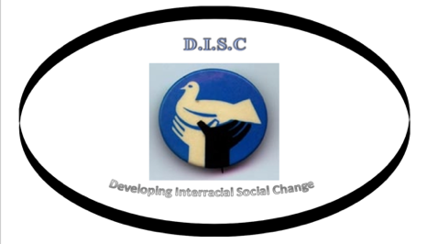

Join us in Celebrating Pearl City and Dixie Manor’s Rising Together Project!
Location: Friendship Baptist Church, 1421 NE 2nd Court, Boca Raton
Date: 6:30pm, Thursday September 15
Sponsor: DISC
You are cordially invited to attend a presentation by the community leaders of DISC on the findings of the Rising Together Project on Public Health and Climate Change, which was funded by a grant from the US. Environmental Protection Agency. DISC is a not-for-profit tax-exempt community organization based in Pearl City that meets monthly to engage in dialogue about community issues. The Rising Together Project was a public health initiative in which DISC leaders served as Outreach Coordinators to survey their neighbors about their perceptions and concerns, and to educate them about strategies to protect themselves from the health impacts of climate change. Participants received a laminated fact sheet on how to stay safe and healthy during extreme weather events such as heat waves and storm surges. They were also offered the opportunity to sign up for CodeRed, the Palm Beach County emergency response system.
The Rising Together Project is part of a larger interfaith effort to respond to climate change in a proactive manner by supporting planning efforts at the municipal level. The Adaptation Action Areas Planning Guidebook for Florida’s Local Governments (2015) presents planning tools and initiatives that can be undertaken to adapt to sea level rise; including an Adaptation Outreach Campaign to “inform community residents …of 1) the potential impacts of sea level rise, 2) the initiatives and programs the community will be or has implemented to address said impacts…, and 3) develop a relationship and understanding of the community needs, including addressing vulnerable populations and health risks associated with sea level rise.”
The response to the Outreach Campaign in the Pearl City/Dixie Manor community was outstanding! We hope you will join us in acknowledging and celebrating the work of our canvassers. Project Manager Dr. Debra Weiss-Randall, who is a Certified Health Education Specialist, supervised the data collection and entry, and will be presenting a summary of the findings.
We look forward to seeing you at 6:30pm Thursday, September 15 at Friendship Baptist Church, 1421 NE 2nd Court, Boca Raton, FL. Please RSVP to: Dr. Debra Weiss-Randall, 914-572-2126, Marjorie O’Sullivan, 561-213-6214 or Marie Hester 703-371-2263.

