Toussaint L’Ouverture High School presents
Rising Together!

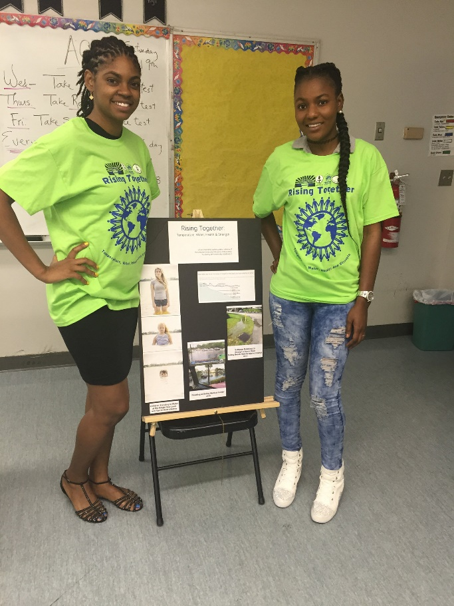

Come honor our students, faculty, & outreach workers for their great work on environmental justice & public health!

Thursday, September 22, 12:30pm

Toussaint L’Ouverture High School Cafeteria
301 SW 14th Ave., Delray Beach

For more info, call Dr. Diane Allerdyce at 561-266-1283.

